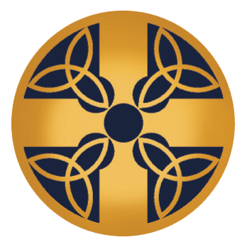
St. Patrick’s Children’s Religious Education
Calendar 2022-2023

Date | Event
September 11 | Religious Education Classes  Classes Meet in Main Hall and Trinity Hall at St. Patrick  (8:45-9:45 AM)
September 18 | Religious Education
September 25 | Religious Education
October 2 | Religious Education (Circle of Grace Lesson)
October 9 | Religious Education
October 16 | Religious Education
October 23 | Religious Education
October 25 | FIRST RECONCILIATION RETREAT (6:00-7:30 PM)
November 6 | Religious Education (Daylight Savings Time Ends)
November 8 | FIRST RECONCILIATION  (6:30 PM in the church)
November 13 | Religious Education
November 20 | Religious Education
December 4 | Religious Education
December 8 | Holy Day of Obligation (Immaculate Conception of the Blessed Virgin Mary)  Check Bulletin or Website for Mass Times
December 11 | Religious Education
December 18 | Religious Education
December 25 | MERRY CHRISTMAS!!
January 8 | Religious Education
January 15 | 2nd Reconciliation for 1st Communion Students
January 15 | Religious Education
January 22 | Reconciliation for First Communion Parents
January 22 | Religious Education
February 5 | Religious Education
February 12 | Religious Education
February 22 | ASH WEDNESDAY  Check Bulletin and Website for Mass Times
February 26 | Religious Education
March 5 | Religious Education
March 26 | Religious Education
April 2 | Religious Education  Palm Sunday
TBD | Seder Meal (First Communicants and Families)  6:00-8:00 PM (St. Brigid Hall)
April 6 | HOLY THURSDAY FOR FIRST COMMUNICANTS
April 9 | EASTER SUNDAY
April 16 | Religious Education
April 23 | Religious Education
April 30 | Religious Education
May 2 | FIRST COMMUNION PICTURES, 4:30-5:45PM  FIRST COMMUNION RETREAT, 6-7:30 PM  FIRST COMMUNION PRACTICE, 6-7:30PM
May 6 | FIRST COMMUNION, 10 AM, CHURCH

