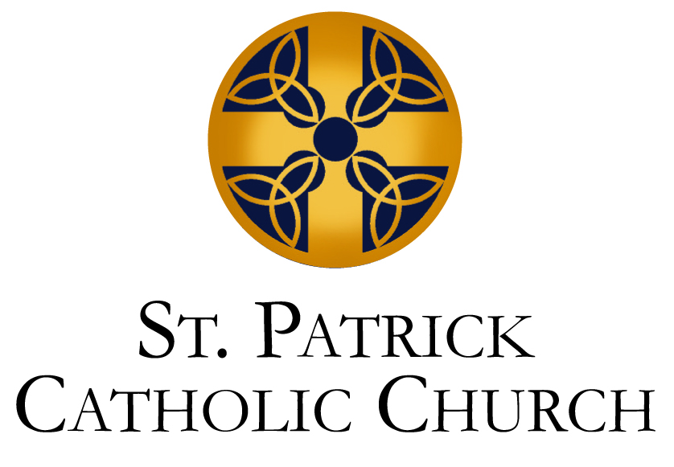
Schedule for Confirmation (2023-2024)
Classes Meet from 6:30-8:00 PM in St. Brigid Hall
Confirmation Leader: Kevin Polonus kpolonus@hotmail.com

2023 2024
September: January:
September 10th (Parent Meeting) January 14th
September 17th January 21st
September 24th January 28th
October: February:
October 1st February 4th
October 8th February 10th
October 14th (Confirmation Retreat at St. John’s, 12-6 pm) (Confirmation Retreat, 12-6 pm)
October 22nd February 18th
February 25th
November: March:
November 5th March 3rd
November 12th March 24th
November 19th
December April:
December 3rd April 7th
December 10th April 14th
December 17th April 21st
April 28th
Confirmation Mass (TBD)

